1. Write a “person” class to hold all the details.

Ans. 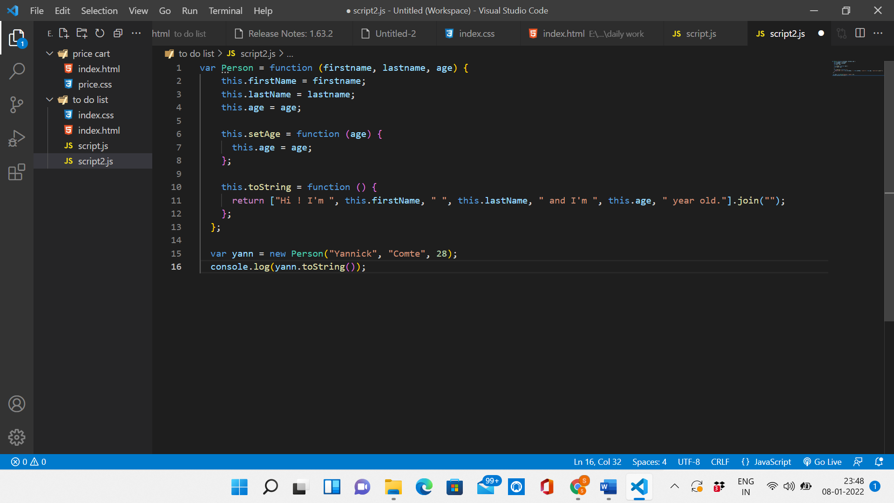

1. write a class to calculate uber price.

